Beaker Breakers Studio
AI-Powered Gamified Virtual Chemistry Laboratory Portal
Software Requirements Specification

Prepared in accordance with IEEE/ISO/IEC 29148:2018
Document Version: 1.0
Status: Draft for Review
September 2026

Prepared by
Syed Mohsin Abbas (BSSE012313006)
Rabail Mehboob (BSCS012313003)

The University of Chenab, Gujrat
Department of Computer Science

Table of Contents
Table of Contents
1. Introduction 3
1.1 Purpose 3
1.2 Scope 3
1.3 Definitions, Acronyms, and Abbreviations 3
2. Stakeholders 5
3. Product Perspective 5
3.1 System Context 5
4. Product Functions 6
5. User Classes and Characteristics 8
6. Operating Environment 8
7. Assumptions and Dependencies 9
8. External Interface Requirements 9
8.1 User Interfaces 9
8.2 Hardware Interfaces 10
8.3 Software Interfaces 10
8.4 Communication Interfaces 10
9. Role-Permission Matrix 11
10. Design Constraints 11
11. Functional Requirements 13
11.1 Authentication and Account Management 13
11.2 Safety Certification 13
11.3 Experiment Management 14
11.4 Knowledge Assessment 14
11.5 Augmented Reality Mode 15
11.6 Gamification 15
11.7 Leaderboard and Daily Missions 16
11.8 AI Readiness Reporting 16
11.9 Teacher Class Management 16
11.10 Administration and Reporting 17
12. Non-Functional Requirements 18
13. Security Requirements 18
14. Domain Requirements 19
15. Inverse Requirements 20
16. Data Requirements, Entity List 21
17. Reporting Requirements 23
18. Backup and Disaster Recovery Requirements 23
19. Audit and Logging Requirements 23
20. Use Cases 25
21. Acceptance Criteria 30
22. Future Enhancements 30

1. Introduction

1.1 Purpose
This document specifies the requirements for Beaker Breakers Studio, an AI-supported virtual chemistry laboratory portal intended for secondary schools. It states what the software is required to do, the qualities it is required to exhibit, and the constraints under which it is required to operate.
The document is written for the project supervisor and the evaluation committee, for the development team who will build the system, and for any party who later maintains it. It is the agreed baseline against which the completed software will be verified.
The software has not yet been built. Every requirement in this document therefore states an obligation on the system that is to be built, rather than describing behaviour that already exists.

1.2 Scope
Beaker Breakers Studio will deliver the practical component of the secondary chemistry syllabus through software. Students will perform curriculum aligned experiments in a virtual laboratory, complete a mandatory four tier safety certification before gaining access to those experiments, receive contextual guidance from an AI assistant while working, and view selected experiments in augmented reality on an ordinary smartphone. Teachers will monitor their classes, assign experiment tasks, and obtain an AI generated assessment of each student readiness for real laboratory work. Administrators will manage enrolment, classes, the experiment library, certificates, and school level reporting.
The following are outside the scope of this specification. The software will not simulate chemical reactions from first principles; reaction outcomes and measured values are authored in advance as part of each experiment definition. The software will not replace a physical laboratory where one exists and is usable. Subjects other than chemistry, and educational levels above secondary, are not covered. Integration with external school management or examination systems is not provided. No instruction relating to the acquisition or handling of real hazardous substances outside the virtual environment will be given.

1.3 Definitions, Acronyms, and Abbreviations
Term | Meaning
AR | Augmented Reality. A view in which computer generated content is overlaid on the live camera image of the real surroundings.
Beaky | The name of the AI assistant avatar presented to students during an experiment.
CSV | Comma Separated Values, the file format accepted for bulk student enrolment.
Experiment session | One occasion on which a student performs an experiment, from the first step until the experiment is completed or abandoned.
FR | Functional Requirement.
JWT | JSON Web Token, the format of the access token issued on successful login.
NFR | Non Functional Requirement.
Performance dimension | One of the six aspects of student performance the system measures: procedural accuracy, safety compliance, reagent management, time efficiency, conceptual understanding, and error recovery.
PII | Personally Identifiable Information.
PKT | Pakistan Standard Time.
RBAC | Role Based Access Control.
Readiness report | A record classifying a student as Not Ready, Approaching Readiness, or Ready for Real Lab, derived from the six performance dimensions.
Safety certificate | The permanent record a student receives after passing all four safety tiers. It carries a unique identifier and the score obtained in each tier.
Safety tier | One of the four units of safety instruction and assessment. Each tier must be passed before the next becomes available.
Simulation AR | The alternative view shown when live augmented reality is unavailable. It offers the same controls and the same experiment without camera input.
SR | Security Requirement.
SRS | Software Requirements Specification.
TLS | Transport Layer Security.
UUID | Universally Unique Identifier.
WCAG | Web Content Accessibility Guidelines.
XP | Experience Points, the score a student accumulates through activity in the system.

Requirement identifiers used in this document are identical to those used in Chapter 3 of the Final Year Project report. FR-02.7, for example, refers to the issuing of the safety certificate in both documents. The modal verb "shall" marks a binding requirement, "will" a statement of expected behaviour, and "should" a recommendation that is not a condition of acceptance.

2. Stakeholders
Stakeholder | Interest / Role
Secondary school students | Primary users. Perform experiments, complete safety certification, and are assessed by the system.
Chemistry teachers | Monitor classes, assign experiment tasks, review readiness reports, and verify safety certificates before permitting real laboratory access.
School administrators | Manage enrolment, classes, the experiment library, and institutional reporting. Approve adoption of the platform.
School management | Fund the subscription and expect measurable improvement in practical science provision.
Parents and guardians | Indirect beneficiaries. Expect their children to receive safe and effective practical science education. They are not users of the system.
Project supervisor and co-supervisor | Provide academic oversight and approve the requirements baseline.
Evaluation committee | Assess the completed project against this specification.
Development team | Design, build, and test the software.
System maintainer | Operates the deployed system after handover, including backup, monitoring, and updates.

3. Product Perspective
Beaker Breakers Studio is a new and self contained product. It does not replace any existing system in the institutions that will adopt it, and it does not require any school system to be present in order to operate.
The product is an institutional platform rather than a consumer application. Accounts are created by a school administrator, students are organised into classes, and all data is scoped to the school that owns it. The product operates in three tiers. Presentation takes place on the client device, all business logic and authority reside on the server, and persistent data is held in server side stores. This arrangement is a constraint on the requirements rather than a design preference, because several requirements in Section 11 depend on the server remaining the sole authority for scoring and certification.

3.1 System Context
The system exchanges data with four categories of human user and five external services. Students, teachers, and administrators interact through the web and mobile clients. The system maintainer interacts with the deployed infrastructure. The external services provide AI guidance and classification, voice synthesis, push notification delivery, transactional email, and real time event delivery.
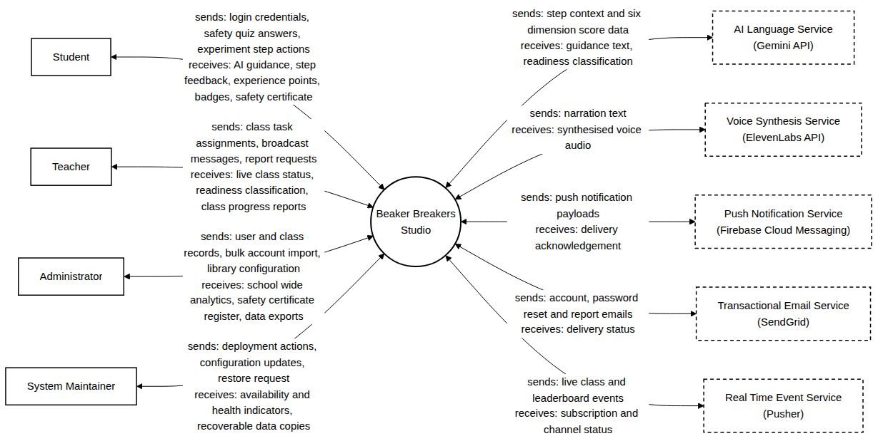
Figure 3.1: System Context Diagram

4. Product Functions
At the highest level the system provides the following functions. Each is expanded into numbered requirements in Section 11.
- Authenticate users and manage the lifecycle of their accounts.
- Deliver four tier safety training and issue a digital safety certificate on completion.
- Present a library of curriculum aligned chemistry experiments and enforce the prerequisites between them.
- Guide a student through each step of an experiment using an AI assistant.
- Assess understanding through a knowledge quiz attached to each experiment.
- Present selected experiments in augmented reality, with an automatic fallback on unsupported devices.
- Award experience points, badges, and rank levels for completed activity.
- Maintain class leaderboards and daily missions.
- Compute six performance dimensions per student and generate a readiness classification for the teacher.
- Provide teachers with live class monitoring, task assignment, and notification broadcast.
- Provide administrators with user, class, library, and certificate management, and school level reporting.
- Record every sensitive administrative action in a permanent audit log.
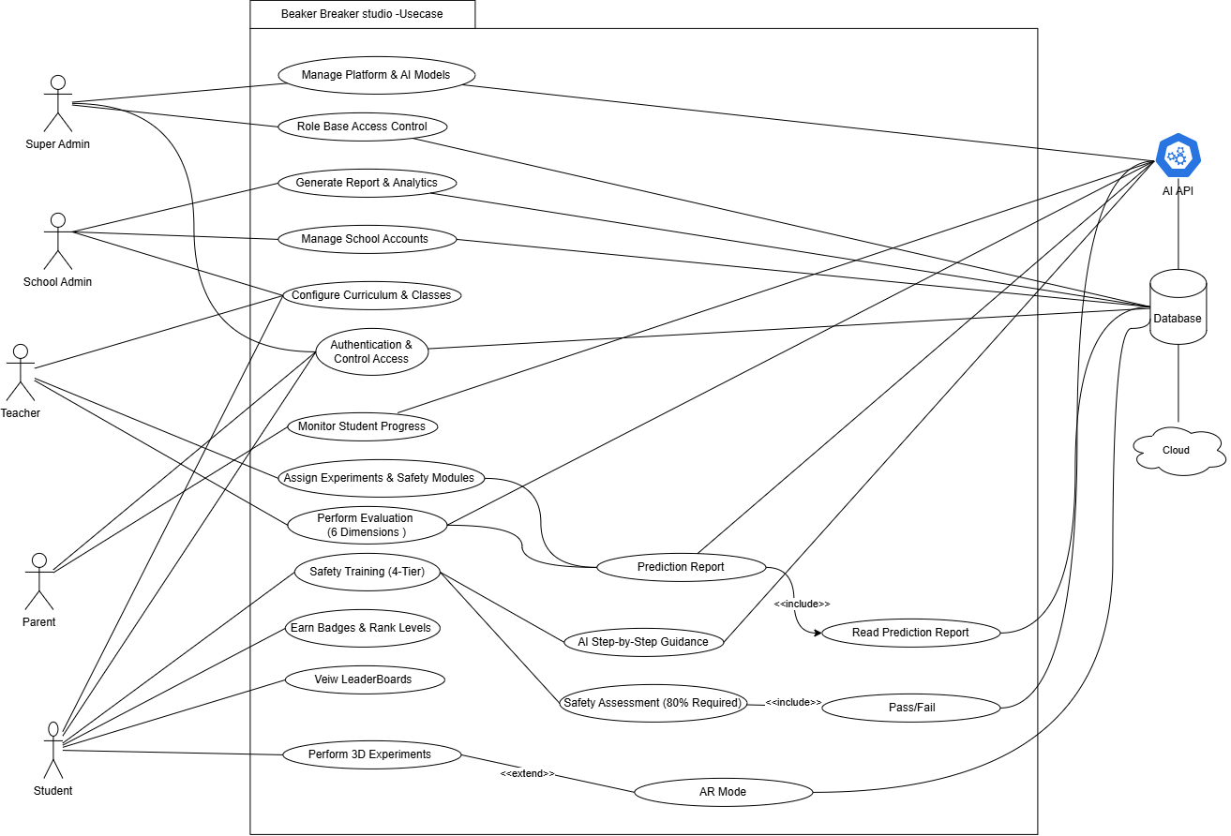
Figure 4.1: Overall Use Case Diagram

5. User Classes and Characteristics
User Class | Characteristics
Student | Aged 13 to 18. Basic familiarity with smartphones or school computers will be assumed; no prior experience of laboratory software will be required. English reading ability at approximately Class 8 level. Many will operate on a shared device and on a limited connection. Students will perform experiments, complete safety certification and earn rewards.
Teacher | Chemistry subject teacher with moderate digital proficiency, who will use the system several times weekly to monitor classes, assign experiment tasks, generate readiness reports and verify safety certificates.
Administrator | School information-technology administrator or principal, familiar with administrative software, who will use the system weekly to manage enrolment, classes, the experiment library, certificates and school-level reporting.
System Maintainer | Technical operator who will be responsible after deployment for backups, monitoring and updates on the cloud infrastructure.

A structured survey of thirteen students, reported in Chapter 3 of the project report, confirmed that the device and connectivity characteristics above are realistic for the intended users. The sample was small and self selected, so the finding is treated as supporting evidence rather than as a statistical result.

6. Operating Environment
Element | Specification
Web client | Chrome 90 or later, Firefox 88 or later, Safari 14 or later, Edge 90 or later, on a device with at least 3 GB of memory and a browser supporting hardware accelerated 3D rendering.
Mobile client | Android 6.0 or later, or iOS 11 or later, with at least 2 GB of memory.
Augmented reality | Android 7.0 or later with ARCore support, or iOS 11 or later with ARKit support. A rear camera and motion sensors are required.
Server | Cloud hosted virtual server with at least 2 virtual CPUs, 4 GB of memory, and 50 GB of storage.
Database | Relational database server with an associated cache instance.
Network | At least 2 Mbps for standard use and 5 Mbps for augmented reality use.
External services | AI language service, voice synthesis service, push notification service, transactional email service, and real time event service, each reachable over HTTPS.

7. Assumptions and Dependencies
The requirements in this document hold only while the following remain true. If any of them ceases to hold, the affected requirements will need to be reviewed.
Assumptions
- Students have access to a device meeting the minimum specification of Section 6, and to a connection of at least the stated minimum bandwidth.
- Accounts are created by a school administrator. There is no public self registration.
- Experiment content, assessment questions, and safety rules are authored and reviewed by qualified subject staff before publication.
- Each student belongs to exactly one class at any given time.
- The adopting school permits student use of a smartphone or computer for the purposes of the subject.
- A teacher is formally assigned to the classes they are expected to monitor, and that assignment is recorded in the system.
Dependencies
- AI step guidance and readiness classification depend on an external AI language service. If that service is unavailable, pre authored guidance is presented instead and every experiment remains completable.
- Augmented reality depends on the tracking framework provided by the mobile operating system. Where the framework is absent, the system presents the Simulation AR view instead.
- Task and broadcast notifications depend on external push notification and email services. Where either is unavailable, the notification is delivered through the in application list.
- Live class monitoring depends on an external real time event service. Where it is unavailable, the teacher view refreshes by polling.
- The external services listed above are assumed to remain available under terms permitting educational use.

8. External Interface Requirements

8.1 User Interfaces
The system presents a web interface for students, teachers, and administrators, and a mobile interface for students. Each role is presented only with the functions permitted to that role. All web interfaces conform to WCAG 2.1 at conformance level AA. Interactive controls have a minimum target area of 44 by 44 pixels, and status is never conveyed by colour alone. The interface adapts to viewport widths from 320 pixels upward without loss of function.

8.2 Hardware Interfaces
The system accesses the rear camera and motion sensors of a mobile device when a student initiates augmented reality presentation, and only for the duration of that presentation. All camera and sensor resources are released when the presentation ends. No other hardware interface is required.

8.3 Software Interfaces
External Service | Purpose | Behaviour on Failure
AI language service | Supplies contextual step guidance (FR-03.7) and readiness classification (FR-08.2). | Pre authored guidance is presented and every experiment remains completable (NFR-06).
Voice synthesis service | Supplies spoken narration for the assistant avatar. | Narration is omitted and text guidance remains available.
Push notification service | Delivers task and broadcast notifications to mobile devices (FR-09.6). | The notification is delivered through the in application notification list.
Transactional email service | Delivers password reset messages (FR-01.3) and welcome messages on bulk import (FR-10.2). | Delivery is retried up to three times within 24 hours.
Real time event service | Delivers live class events to the teacher view (FR-09.3). | The teacher view refreshes by polling at an interval not exceeding 30 seconds.

8.4 Communication Interfaces
All communication between client and server uses HTTPS with TLS 1.3 or later. Server functions are exposed through a REST interface returning JSON. Every request to a protected endpoint carries a signed access token, and any request without a valid token is rejected. Student personally identifiable information is not transmitted to any external service.

9. Role-Permission Matrix
The following matrix defines module level access permissions per user role. F denotes full access, R denotes read only access, L denotes limited access confined to a subset of actions defined in Section 11, and None denotes no access.
Module | Student | Teacher | Administrator
Own account and profile | F | F | F
User account management | None | None | F
Class management | None | R (own classes) | F
Safety training and certification | F (own) | R (own class) | R (school)
Experiment library | R | R | F
Experiment execution | F (own) | None | None
Knowledge quizzes | F (own) | R (own class) | R (school)
Augmented reality mode | F | None | None
Gamification and rewards | R (own) | R (own class) | R (school)
Leaderboard | R (own class) | R (own class) | R (school)
AI readiness reports | R (own) | F (own class) | R (school)
Task assignment | R (assigned) | F (own class) | None
Notification broadcast | None | F (own class) | None
Certificate registry | R (own) | R (own class) | F (school)
School analytics and exports | None | L (own class) | F
Audit log | None | None | R

10. Design Constraints
ID | Constraint
CON-01 | All scores, pass determinations, certificate issue decisions, and reward awards shall be computed on the server. No such value computed by a client shall be accepted.
CON-02 | Role based access control shall be enforced on the server for every protected request, independently of any restriction applied in the client interface.
CON-03 | The system shall operate on client devices meeting no more than the minimum specification stated in Section 6.
CON-04 | The system shall be delivered as a web application and a mobile application. No additional component shall be required to be installed on a school computer.
CON-05 | Student data shall be stored and processed in a manner compliant with the Prevention of Electronic Crimes Act 2016.
CON-06 | All content shall be presented in English in the first release.
CON-07 | The first release shall be completed within a nine month development schedule.
CON-08 | The system shall not require specialist augmented reality hardware.

11. Functional Requirements
The requirements in this section state what the system is required to do. Identifiers and wording are identical to Chapter 3 of the project report.

11.1 Authentication and Account Management
How users gain access to the system, and how their accounts are created, suspended, and removed.
ID | Requirement Statement
FR-01.1 | The system shall provide role-based login for Student, Teacher and Administrator, and shall direct each role to its own dashboard.
FR-01.2 | The system shall authenticate requests using signed access tokens valid for 24 hours from issue.
FR-01.3 | The system shall provide email-based password reset using single-use tokens that shall expire 60 minutes after issue.
FR-01.4 | The system shall reject further login attempts from an address after 5 failed attempts within 15 minutes.
FR-01.5 | The system shall permit only the Administrator to create, edit, suspend and delete user accounts, and shall retain a deleted account in a recoverable state for 30 days.
FR-01.6 | The system shall not provide any means by which a person may create an account without administrator action.

11.2 Safety Certification
The four tier safety training programme, the assessment at the end of each tier, and the certificate issued once all four have been passed.
ID | Requirement Statement
FR-02.1 | The system shall present safety instruction and assessment in four sequential tiers: Basic Lab Rules, Chemical Handling, Fire and Heat Safety, and First Aid and Emergency.
FR-02.2 | The system shall make a tier available to a student only after the preceding tier has been passed with a score of at least 80 percent.
FR-02.3 | The system shall prevent a student from opening any experiment until Tier 1 has been passed.
FR-02.4 | The system shall select tier assessment questions at random from the question bank of that tier on each attempt.
FR-02.5 | The system shall compute every assessment score on the server and shall not accept a score computed by the client.
FR-02.6 | The system shall permit a student to reattempt a failed tier assessment without limit.
FR-02.7 | The system shall issue a digital safety certificate bearing a unique identifier, the four tier scores and the date of issue, once all four tiers have been passed.
FR-02.8 | The system shall not issue a certificate to a student whose score in any tier is below 80 percent, and shall not delete or revoke an issued certificate.
FR-02.9 | The system shall display an issued certificate on the student profile and to the teacher assigned to that student’s class.

11.3 Experiment Management
The experiment library, the order in which experiments may be attempted, and the guidance a student receives while working through one.
ID | Requirement Statement
FR-03.1 | The system shall provide a library of no fewer than 30 chemistry experiments aligned to the Class 9 and Class 10 curriculum.
FR-03.2 | The system shall permit a student to filter the experiment library by difficulty and by topic.
FR-03.3 | The system shall prevent a student from opening an experiment whose prerequisite experiment has not been completed, and shall display the reason.
FR-03.4 | The system shall present experiment steps in their declared order and shall require each step to be completed before the next is presented.
FR-03.5 | The system shall record the completion of each step to persistent storage at the time of completion, and shall restore completed steps when a student resumes an incomplete experiment.
FR-03.6 | The system shall display the governing chemical equation and an explanatory note for each experiment.
FR-03.7 | The system shall present contextual AI guidance for the current step within 2 seconds, or within 200 milliseconds where that guidance has been cached.
FR-03.8 | The system shall permit a student to repeat a completed experiment without limit.

11.4 Knowledge Assessment
The quiz attached to each experiment, the feedback given on each answer, and the reward awarded on a first pass.
ID | Requirement Statement
FR-04.1 | The system shall make an experiment’s knowledge quiz available only after all steps of that experiment have been completed.
FR-04.2 | The system shall indicate whether each submitted answer is correct or incorrect immediately, and shall present an explanatory note where the answer is incorrect.
FR-04.3 | The system shall award the experience points of an experiment once only, upon the first score of at least 80 percent.
FR-04.4 | The system shall record every quiz attempt with its score, the answers submitted and the time of submission.
FR-04.5 | The system shall permit a student to reattempt a failed quiz, presenting the questions in a different order on each attempt.

11.5 Augmented Reality Mode
Presentation of an experiment in augmented reality, together with the fallback provided where a device cannot support it.
ID | Requirement Statement
FR-05.1 | The system shall provide augmented reality presentation for no fewer than 4 experiments.
FR-05.2 | The system shall request camera permission before initiating augmented reality presentation.
FR-05.3 | The system shall detect a horizontal surface within 3 seconds on a supported device under normal indoor lighting, and shall anchor the experiment overlay to that surface.
FR-05.4 | The system shall present a clearly labelled simulated presentation within 1 second where the device is unsupported, camera permission is refused, or no surface is detected.
FR-05.5 | The system shall provide the same experiment controls in the simulated presentation as in the live presentation.
FR-05.6 | The system shall release all camera and motion sensor resources when augmented reality presentation ends.

11.6 Gamification
Experience points, badges, rank levels, and activity streaks, and the behaviour these are intended to encourage.
ID | Requirement Statement
FR-06.1 | The system shall award experience points on completion of an experiment according to its difficulty, and on the passing of a safety tier.
FR-06.2 | The system shall not award experience points for the speed at which a student completes an experiment or a quiz.
FR-06.3 | The system shall provide no fewer than 60 distinct badges, each of which shall be awarded to a given student no more than once.
FR-06.4 | The system shall assign a student to one of 8 rank levels according to cumulative experience points, and shall not reduce a student’s points or rank level under any operation.
FR-06.5 | The system shall record consecutive days of activity and shall award a badge at 7, 30 and 100 consecutive days.

11.7 Leaderboard and Daily Missions
What the class leaderboard shows, how quickly it updates, and the daily missions presented to each student.
ID | Requirement Statement
FR-07.1 | The system shall present a class leaderboard showing only display name, avatar, rank level and cumulative experience points.
FR-07.2 | The system shall reflect a change in experience points on the leaderboard within 2 seconds of the awarding event.
FR-07.3 | The system shall present 3 daily missions to each student, replacing them at midnight Pakistan Standard Time.

11.8 AI Readiness Reporting
The six performance dimensions the system measures, and the readiness classification a teacher obtains from them.
ID | Requirement Statement
FR-08.1 | The system shall compute six performance dimensions for each student: procedural accuracy, safety compliance, reagent management, time efficiency, conceptual understanding and error recovery.
FR-08.2 | The system shall generate a readiness report on a teacher’s request and shall present it within 5 seconds.
FR-08.3 | The system shall classify the subject of a readiness report as Not Ready, Approaching Readiness, or Ready for Real Lab.
FR-08.4 | The system shall decline to generate a report for a student who has completed fewer than 3 experiments, and shall state the reason.
FR-08.5 | The system shall record each generated report with the teacher, the student, the six dimension values, the classification and the time of generation.
FR-08.6 | The system shall present to a student their own dimension values and classification, and shall not present those of any other student.

11.9 Teacher Class Management
Class monitoring, task assignment, and notification. Every requirement here is bounded by the classes assigned to the teacher.
ID | Requirement Statement
FR-09.1 | The system shall restrict every teacher action to students of a class to which that teacher is formally assigned, and shall reject any other request.
FR-09.2 | The system shall present to a teacher, for each student of an assigned class, the cumulative experience points, the number of experiments completed, the safety certification status and the most recent activity time.
FR-09.3 | The system shall update the teacher class view within 5 seconds of an event affecting a displayed value.
FR-09.4 | The system shall permit a teacher to assign an experiment task to an individual student, a group, or an entire assigned class, with a due date, and shall reject a due date that is not in the future.
FR-09.5 | The system shall record the state of each task assignment as Assigned, In Progress, Completed or Overdue, and shall change that state without teacher intervention when the governing condition occurs.
FR-09.6 | The system shall deliver notification of a newly assigned task to each targeted student within 60 seconds.
FR-09.7 | The system shall permit a teacher to broadcast a notification of type task, reminder, safety alert or announcement to an assigned class, limited to 500 characters with markup removed.

11.10 Administration and Reporting
Institutional management of users, classes, content, and certificates, together with school level reporting and the audit record.
ID | Requirement Statement
FR-10.1 | The system shall permit the Administrator to create and modify classes and to assign students and teachers to them.
FR-10.2 | The system shall accept bulk creation of student accounts from a delimited file of no more than 500 rows, completing within 60 seconds.
FR-10.3 | The system shall create no account from a bulk file in which any row fails validation, and shall report each failing row individually.
FR-10.4 | The system shall permit the Administrator to enable or disable an experiment for a specified class with immediate effect.
FR-10.5 | The system shall maintain a school-wide register of issued safety certificates and shall permit its export.
FR-10.6 | The system shall generate school-level analytics comprising the certification rate, the experiment completion rate and the distribution of readiness classifications.
FR-10.7 | The system shall export a generated report in portable document format or delimited text within 10 seconds.
FR-10.8 | The system shall record every administrative account operation, certificate issue and report export as an entry that shall not subsequently be modified or deleted, and shall retain such entries for no less than 7 years.

12. Non-Functional Requirements
These requirements state the qualities the system is required to exhibit. They are verified by measurement rather than by observing a function.
ID | Requirement Statement
NFR-01 | The system shall return a response to a server request within 300 milliseconds at the 95th percentile, excluding requests to the external AI service.
NFR-02 | The web portal shall achieve first contentful paint within 3 seconds over a 4 megabit per second connection.
NFR-03 | The system shall be hosted on cloud infrastructure and shall be available in no less than 99.5 percent of each calendar month.
NFR-04 | The system shall serve 1000 concurrent authenticated users without exceeding the response time stated in NFR-01.
NFR-05 | The system shall not lose any recorded student progress, experience points, badge award or certificate as a consequence of a page refresh, a session expiry or a network interruption.
NFR-06 | The system shall present pre-authored guidance and shall permit every experiment to be completed when the external AI service is unavailable.
NFR-07 | A student who has not previously used the system shall be able to complete login, Tier 1 safety training and a first experiment without assistance from another person.
NFR-08 | All web interfaces shall conform to the Web Content Accessibility Guidelines 2.1 at conformance level AA.
NFR-09 | The portal shall operate correctly on Chrome 90 and later, Firefox 88 and later, Safari 14 and later, and Edge 90 and later.
NFR-10 | Automated test coverage shall be no less than 70 percent overall and 100 percent for authentication, score computation, reward award and safety certification logic.
NFR-11 | The system shall operate on a client device having 3 gigabytes of memory and a browser supporting hardware-accelerated 3D rendering.
NFR-12 | Augmented reality surface detection shall complete within 3 seconds on at least 5 tested Android models and 2 tested iOS models.

13. Security Requirements
These requirements protect the integrity of student records, the confidentiality of personal data, and the credibility of the assessment outcomes the system produces.
ID | Requirement Statement
SR-01 | The system shall store passwords only as salted hashes produced by an adaptive hashing function with a work factor of no less than 12.
SR-02 | The system shall conduct all communication over TLS 1.3 or later.
SR-03 | The system shall reject with an authentication error any request to a protected function that does not carry a valid access token.
SR-04 | The system shall enforce role-based access control on the server, and shall reject with an authorisation error any request outside the permissions of the caller’s role.
SR-05 | The system shall expire a user session after 24 hours of inactivity and shall invalidate all tokens of a user whose password is changed or whose account is suspended.
SR-06 | The system shall encrypt student personally identifiable information while stored.
SR-07 | The system shall validate every input on the server irrespective of any validation performed by the client.
SR-08 | The system shall not present to a student the score, safety history, readiness classification or assessment record of any other student.
SR-09 | The system shall not present or generate content relating to the acquisition or handling of hazardous substances outside the virtual environment.
SR-10 | The system shall create a recoverable copy of all retained data at intervals not exceeding 24 hours and shall retain each copy for no less than 30 days.

14. Domain Requirements
These requirements arise from the rules of secondary chemistry education and of laboratory safety practice rather than from any stakeholder preference. They cannot be negotiated away without changing the educational purpose of the system.
ID | Requirement Statement
DR-01 | Experiment content shall follow the National Curriculum of Pakistan for Chemistry, Grades IX and X.
DR-02 | The pass mark of 80 percent applied to safety tier assessments and to knowledge quizzes shall be treated as fixed institutional policy and shall not be lowered by any user of the system.
DR-03 | Safety training shall precede practical work in all cases, in keeping with standard laboratory practice.
DR-04 | The four safety tiers shall be completed in the order Basic Lab Rules, Chemical Handling, Fire and Heat Safety, First Aid and Emergency, because each tier assumes the knowledge of the one before it.
DR-05 | An issued safety certificate shall constitute a permanent academic record and shall not be revoked or deleted.
DR-06 | Student accounts shall be created only by an authorised school administrator, as school enrolment is an institutional act rather than an individual one.
DR-07 | Chemical hazard information presented by the system shall correspond to the recognised hazard classification for that substance.

15. Inverse Requirements
These requirements state what the system shall not do. They are recorded separately because each of them protects either the safety of a student or the credibility of an assessment result, and because a reader verifying the system needs to be able to test for their absence.
ID | Requirement Statement
IR-01 | The system shall not permit a student to open or execute any experiment before Safety Tier 1 has been passed.
IR-02 | The system shall not accept any score, experience point value, or pass decision computed by a client.
IR-03 | The system shall not decrease a student accumulated experience points or rank level under any operation.
IR-04 | The system shall not award experience points more than once for the same experiment.
IR-05 | The system shall not expose the scores, safety history, readiness classification, or assessment records of one student to another student.
IR-06 | The system shall not permit a teacher to view or act upon a student outside the classes to which that teacher is formally assigned.
IR-07 | The system shall not issue a safety certificate where the score in any tier is below 80 percent.
IR-08 | The system shall not provide instructions or AI generated content relating to the acquisition or handling of real hazardous materials outside the virtual environment.
IR-09 | The system shall not permit modification or deletion of an entry once written to the audit log.
IR-10 | The system shall not provide any means by which a person may create an account without administrator action.
IR-11 | The system shall not award experience points on the basis of the speed at which a student completes an experiment or a quiz.

16. Data Requirements, Entity List
The system retains the following entities. Attributes are stated at the level needed to understand the relationships between them; the physical schema is a matter for the design.
Entity | Purpose | Key Attributes
schools | One record per adopting institution. All other data is scoped to a school. | school_id, name, address, subscription_status
users | One record per person who signs in, of any role. | user_id, school_id, name, email, password_hash, role, status
student_profiles | Student specific data held separately from the general user record. | profile_id, user_id, class_id, total_points, rank_level
classes | A teaching class within a school. | class_id, school_id, name, academic_year
class_teachers | Links teachers to the classes they are assigned to teach. | class_id, user_id
experiments | One record per experiment in the library. | experiment_id, title, difficulty, objective, theory, equation, prerequisite_id
experiment_steps | The ordered steps of an experiment. | step_id, experiment_id, step_index, instruction, expected_observation
experiment_quiz_questions | The question bank for an experiment knowledge quiz. | question_id, experiment_id, text, options, correct_index
safety_tier_questions | The question bank for each of the four safety tiers. | question_id, tier, text, options, correct_index
experiment_sessions | One record per occasion on which a student performs an experiment. | session_id, student_id, experiment_id, started_at, completed_at, steps_completed, status
safety_attempts | One record per attempt at a safety tier assessment. | attempt_id, student_id, tier, score, passed, attempted_at
certificates | The safety certificate issued to a student. At most one per student. | certificate_id, student_id, tier_scores, issued_at
readiness_reports | One record per generated readiness report. | report_id, student_id, teacher_id, dimension_scores, classification, generated_at
rewards | Experience points and badges awarded to a student. | reward_id, student_id, type, value, source_event, awarded_at
tasks | An experiment assigned by a teacher. | task_id, teacher_id, experiment_id, class_id, due_date, created_at
task_assignments | One record per student targeted by a task, carrying that student state. | assignment_id, task_id, student_id, state
notifications | Messages delivered to users. | notification_id, recipient_id, type, title, body, sent_at
fcm_tokens | Device registration tokens used for push notification delivery. | token_id, user_id, token, platform, registered_at
audit_logs | A permanent record of sensitive administrative actions. | log_id, actor_id, action, target, timestamp

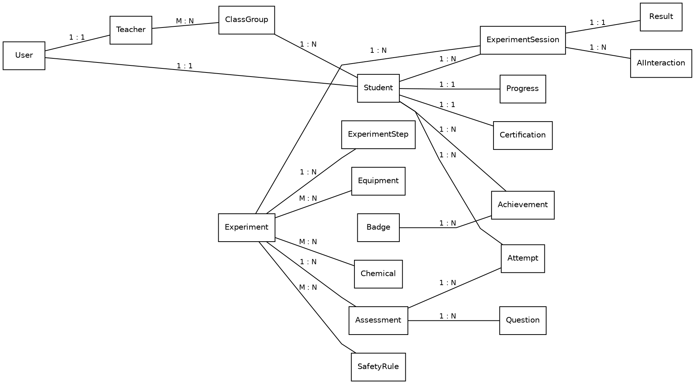
Figure 16.1: Entity Relationship Diagram

17. Reporting Requirements
ID | Requirement Statement
RR-01 | The system shall provide a teacher with a class level report covering experiments completed, certification status, and readiness classification for each student of an assigned class.
RR-02 | The system shall provide an administrator with a school level report covering the certification rate, the experiment completion rate, and the distribution of readiness classifications.
RR-03 | The system shall export any generated report in portable document format or delimited text within 10 seconds of the request.
RR-04 | The system shall provide a student with a personal progress view showing experiments completed, rewards earned, certification status, and their own readiness classification.
RR-05 | The system shall record the identity of the user who generates or exports any report, together with the time of the request.

18. Backup and Disaster Recovery Requirements
ID | Requirement Statement
BR-01 | The system shall create a full backup of all persistent data at intervals not exceeding 24 hours.
BR-02 | The system shall retain each backup for no less than 30 days.
BR-03 | The system shall permit restoration from a backup within 4 hours of a failure that renders the primary data store unusable.
BR-04 | The ability to restore from backup shall be tested at least once each quarter, and the result of each test shall be recorded.
BR-05 | Backups shall be stored separately from the primary data store and shall be encrypted at rest.

19. Audit and Logging Requirements
ID | Requirement Statement
AL-01 | The system shall record every successful and failed authentication attempt with the user identifier, the originating address, and the time.
AL-02 | The system shall record every administrative creation, modification, suspension, and deletion of a user account.
AL-03 | The system shall record every issue of a safety certificate and every export of a report.
AL-04 | The system shall record every rejected attempt to access data outside the permissions of the requesting role.
AL-05 | The system shall retain audit entries for no less than 7 years, and shall not permit an entry to be modified or deleted once written.
AL-06 | The system shall make the audit log readable by an administrator and by no other role.

20. Use Cases
The following use cases describe the principal interactions between the actors and the system. Each is traced to the functional requirements it exercises.
Figure 20.1: Use Case Diagram

UC-01: Log In
Field | Description
Actor | Student, Teacher, Administrator
Preconditions | The user holds an account created by a school administrator.
Main Flow | 1. User opens the application and enters school identifier and password. 2. System validates the credentials. 3. System issues an access token. 4. System loads the dashboard belonging to the user role.
Alternate Flow | If the credentials are invalid, the system displays a message that does not indicate which credential was wrong. After five failed attempts within fifteen minutes, further attempts from that address are refused.
Postconditions | The user is authenticated and the correct role dashboard is displayed.
Related Requirements | FR-01.1, FR-01.2, FR-01.4
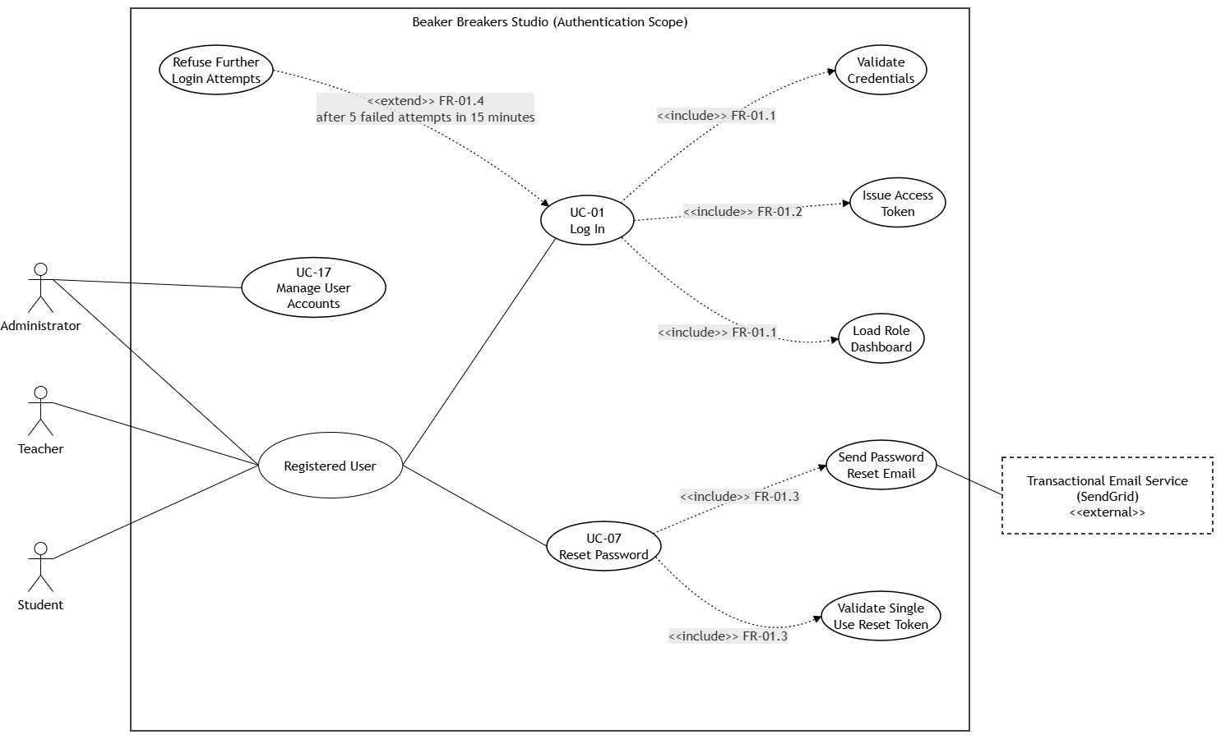
UC-02: Safety Certification
Field | Description
Actor | Student
Preconditions | The student is authenticated.
Main Flow | 1. Student opens Safety Training. 2. System presents the lowest tier not yet passed. 3. Student studies the tier material and starts the assessment. 4. System presents questions selected at random from the tier bank. 5. Student submits answers. 6. System computes the score on the server. 7. On a score of 80 percent or above the tier is marked passed and the next tier is unlocked. 8. When all four tiers are passed the system issues the safety certificate.
Alternate Flow | On a score below 80 percent the system displays the result and offers a further attempt with a fresh selection of questions. The number of attempts is not limited.
Postconditions | The tier is recorded as passed, or the certificate is issued if this was the fourth tier.
Related Requirements | FR-02.1 to FR-02.9
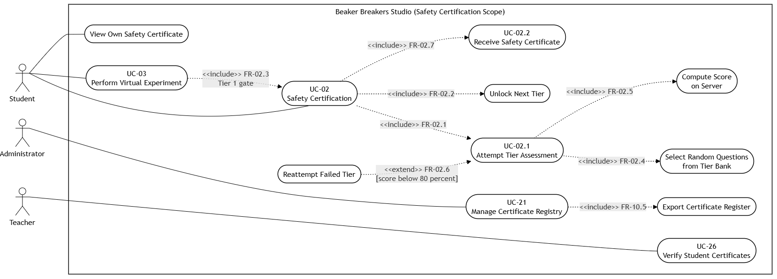
UC-03: Perform Virtual Experiment
Field | Description
Actor | Student
Preconditions | The student is authenticated and has passed Safety Tier 1.
Main Flow | 1. Student selects an experiment from the library. 2. System verifies that any prerequisite experiment has been completed. 3. System presents the first step. 4. Student completes each step in turn while the AI assistant provides guidance. 5. System records the completion of each step. 6. When all steps are complete the knowledge quiz is unlocked.
Alternate Flow | If the AI service does not respond, pre authored guidance is presented and the experiment remains completable. If the student leaves and returns, completed steps are restored.
Postconditions | The experiment is recorded as complete and the knowledge quiz becomes available.
Related Requirements | FR-03.1 to FR-03.8, NFR-05, NFR-06

UC-04: AR Mode Session
Field | Description
Actor | Student
Preconditions | The student is authenticated and has selected an AR enabled experiment.
Main Flow | 1. Student taps Launch AR. 2. System checks whether the device supports augmented reality. 3. System requests camera permission. 4. System scans for a flat surface and anchors the experiment overlay to it. 5. Student performs the experiment using the rotate, guidance, and exit controls. 6. On exit the system stops the camera stream and releases device resources.
Alternate Flow | Where the device is unsupported, permission is refused, or no surface is detected, the system presents the clearly labelled Simulation AR view within one second. The same controls are available and the experiment remains complete.
Postconditions | The experiment is performed and all camera resources are released.
Related Requirements | FR-05.1 to FR-05.6

UC-05: Generate AI Readiness Report
Field | Description
Actor | Teacher
Preconditions | The teacher is authenticated and the subject student belongs to a class assigned to that teacher.
Main Flow | 1. Teacher opens AI Readiness and selects a student. 2. System verifies the class assignment. 3. System verifies that the student has completed at least three experiments. 4. System computes the six performance dimensions. 5. System submits the dimension data to the AI service. 6. System records the returned classification and presents the report.
Alternate Flow | If the student belongs to another class the request is refused and the refusal is logged. If fewer than three experiments have been completed the system explains the data requirement and generates no report. If the AI service does not respond the teacher is offered a retry.
Postconditions | A readiness report is stored and displayed, or the reason for not generating one is shown.
Related Requirements | FR-08.1 to FR-08.6, FR-09.1

UC-06: Assign Task
Field | Description
Actor | Teacher
Preconditions | The teacher is authenticated and the target students belong to a class assigned to that teacher.
Main Flow | 1. Teacher opens Task Assignment and selects an experiment, a target, and a due date. 2. System validates the due date and the class assignment. 3. System creates the task and one assignment record per targeted student. 4. System notifies each targeted student. 5. System advances the state of each assignment as the student works. 6. Teacher follows the states on the class dashboard.
Alternate Flow | A due date that is not in the future is rejected with a validation message. A target outside the teacher assigned class is refused and the refusal is logged.
Postconditions | The task is created, the students are notified, and the states are visible to the teacher.
Related Requirements | FR-09.1 to FR-09.7

UC-09: Take Knowledge Quiz
Field | Description
Actor | Student
Preconditions | All steps of the experiment have been completed.
Main Flow | 1. Student opens the quiz. 2. System presents the questions. 3. Student submits answers. 4. System grades the submission on the server and shows whether each answer was correct, with an explanation where it was not. 5. On a first score of 80 percent or above the system awards the experience points of that experiment and updates the leaderboard.
Alternate Flow | On a score below 80 percent the attempt is recorded and a further attempt is offered with the questions in a different order. No further points are awarded on a repeat pass.
Postconditions | The attempt is recorded and, on a first pass, the reward is awarded.
Related Requirements | FR-04.1 to FR-04.5, FR-07.2

UC-18: Bulk Import Students
Field | Description
Actor | Administrator
Preconditions | The administrator is authenticated.
Main Flow | 1. Administrator opens Student Management and uploads a delimited file of up to 500 rows. 2. System validates every row. 3. System creates the accounts and sends a welcome message to each new student. 4. System writes an audit entry for the operation.
Alternate Flow | If any row fails validation no account is created from the file, and the system reports each failing row individually.
Postconditions | The accounts exist and the operation is recorded in the audit log.
Related Requirements | FR-10.2, FR-10.3, FR-10.8

The use case diagrams identify twenty eight use cases in total. The eight below are specified in detail because each one crosses several parts of the system or carries a decision that the requirements depend on. The remainder are single step interactions whose behaviour is already fully stated in Section 11.
Actor | Use cases shown in the diagrams
Student | UC-01 Log In, UC-02 Safety Certification (including UC-02.1 Attempt Tier Quiz and UC-02.2 Receive Safety Certificate), UC-03 Perform Virtual Experiment, UC-04 AR Mode Session, UC-07 Reset Password, UC-08 Browse Experiment Library, UC-09 Take Knowledge Quiz, UC-10 Earn Rewards, UC-11 Daily Missions and Streaks, UC-12 View Leaderboard, UC-13 View Own Readiness Status, UC-25 Receive AI Step Guidance
Teacher | UC-01 Log In, UC-05 Generate AI Readiness Report, UC-06 Assign Task (including UC-06.1 Track Task Status), UC-12 View Leaderboard for own class, UC-14 Monitor Class, UC-15 Broadcast Notification, UC-16 Review Class Reports, UC-26 Verify Student Certificates
Administrator | UC-01 Log In, UC-17 Manage User Accounts, UC-18 Bulk Import Students, UC-19 Manage Classes, UC-20 Configure Experiment Library, UC-21 Manage Certificate Registry, UC-22 Generate Analytics and Export Reports, UC-27 Record Audit Entry

Activity diagrams for the safety certification, virtual experiment, augmented reality, readiness reporting, and task assignment workflows are given in Chapter 4 of the project report. Space is reserved below for the two workflows most often reviewed alongside this specification.
[ Insert Activity Diagram: Safety Certification here ]

Figure 20.2: Activity Diagram, Safety Certification

[ Insert Activity Diagram: Perform Virtual Experiment here ]

Figure 20.3: Activity Diagram, Perform Virtual Experiment

21. Acceptance Criteria
The system will be accepted when the following criteria are met. Each criterion is verifiable by test, demonstration, inspection, or analysis as indicated.
ID | Acceptance Criterion | Method
AC-01 | A student cannot open any experiment until Safety Tier 1 has been passed at 80 percent or above. | Test
AC-02 | A safety certificate is issued only after all four tiers have been passed, and never where any tier falls below 80 percent. | Test
AC-03 | The experiment library contains at least 30 curriculum aligned experiments. | Inspection
AC-04 | Experience points for an experiment are awarded exactly once, on the first quiz pass, and are never reduced. | Test
AC-05 | A score submitted by a client is rejected, and the score computed on the server is used instead. | Test
AC-06 | An unsupported device, a refused camera permission, and a failure to detect a surface each result in the Simulation AR view within one second. | Test
AC-07 | A readiness report is generated within five seconds for a student with at least three completed experiments, and is refused with an explanation below that threshold. | Test
AC-08 | A teacher request concerning a student outside the assigned class is refused and the refusal appears in the audit log. | Test
AC-09 | A bulk import containing one invalid row creates no accounts and reports the failing row. | Test
AC-10 | Completed steps, points, badges, and certificates survive a page refresh, a session expiry, and a network interruption. | Test
AC-11 | With the AI service unavailable, every experiment remains completable using pre authored guidance. | Demonstration
AC-12 | A student who has not used the system before completes login, Tier 1, and one experiment without assistance. | Demonstration
AC-13 | All web interfaces pass a WCAG 2.1 Level AA audit. | Inspection
AC-14 | Response time remains within 300 milliseconds at the 95th percentile with 1000 concurrent users. | Analysis
AC-15 | Automated test coverage is at least 70 percent overall and 100 percent for authentication, scoring, reward, and certification logic. | Analysis

22. Future Enhancements
The following capabilities are outside the first release. They are recorded here so that the design does not foreclose them.
Enhancement | Rationale
Urdu language interface | Would widen access substantially among government school students. Requires the whole experiment library and question bank to be translated.
Full offline operation with deferred synchronisation | Requested by a survey respondent. Requires conflict resolution that the first release architecture does not provide.
Supervised practice outside timetabled hours | Elicitation identified students who wished to practise in free periods but had no supervision available. Requires a scheduling model not yet specified.
Expansion of the experiment library beyond 30 experiments | Growth beyond the minimum is content authoring rather than software change.
Collaborative multi student experiment sessions | Would allow group work in the virtual laboratory. Requires shared session state.
Parent or guardian read only access | Would let parents follow certification and progress. Requires an additional user class with its own privacy treatment.
Teacher authored experiments | Would let subject staff extend the library without developer involvement. Requires an authoring interface with review workflow.
Physics and biology laboratories | The same framework would support other practical sciences.
Recognition of the digital safety certificate by examination boards | Would give the certificate standing outside the adopting school.

